Surface Gap

Definition
# Source: AI Source: Provided by: [Data Path: Persons Table -> ID Column: 1, Name_En Column: Motasem Essam] -> From: [ChatGPT] on [7/25/2026]
A Surface Gap is the empty three-dimensional space separating two surfaces or surface regions.
It describes the spatial separation between surfaces that do not touch, intersect, or coincide.
For two surfaces $S_{1}$and $S_{2}$, the minimum surface gap can be represented as:
$$\boxed{g=d\left(S_{1} , S_{2}\right)}$$
where $d\left(S_{1} , S_{2}\right)$is the minimum distance between points on the two surfaces.
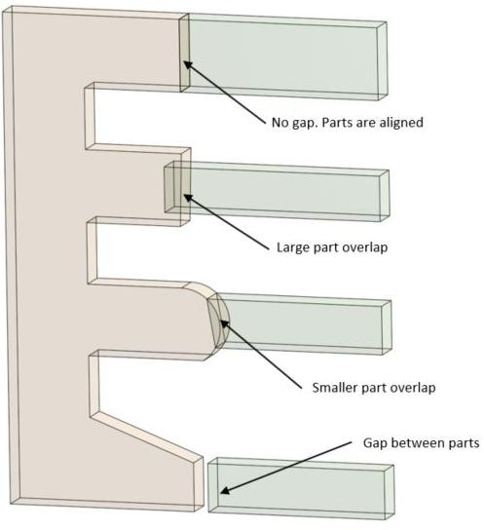
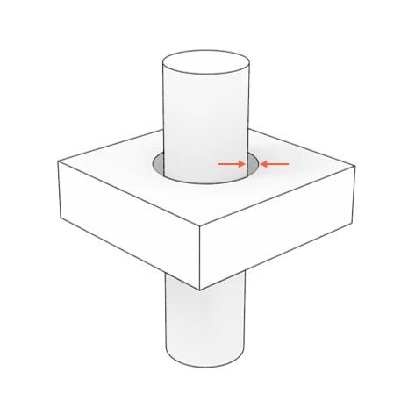
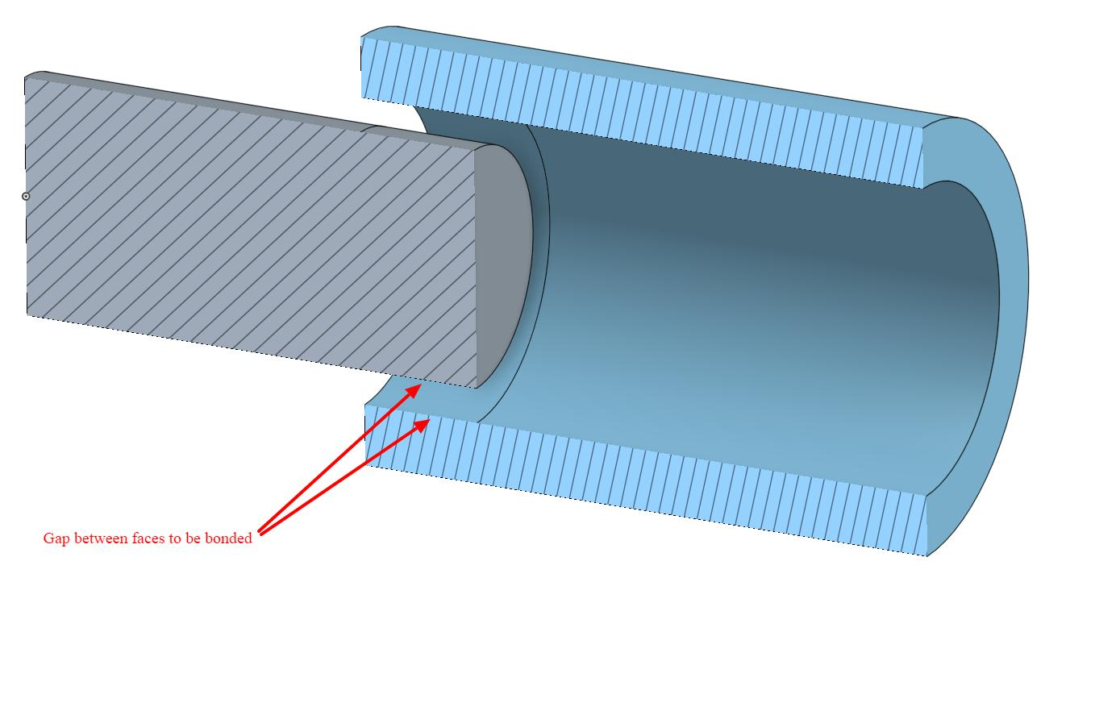
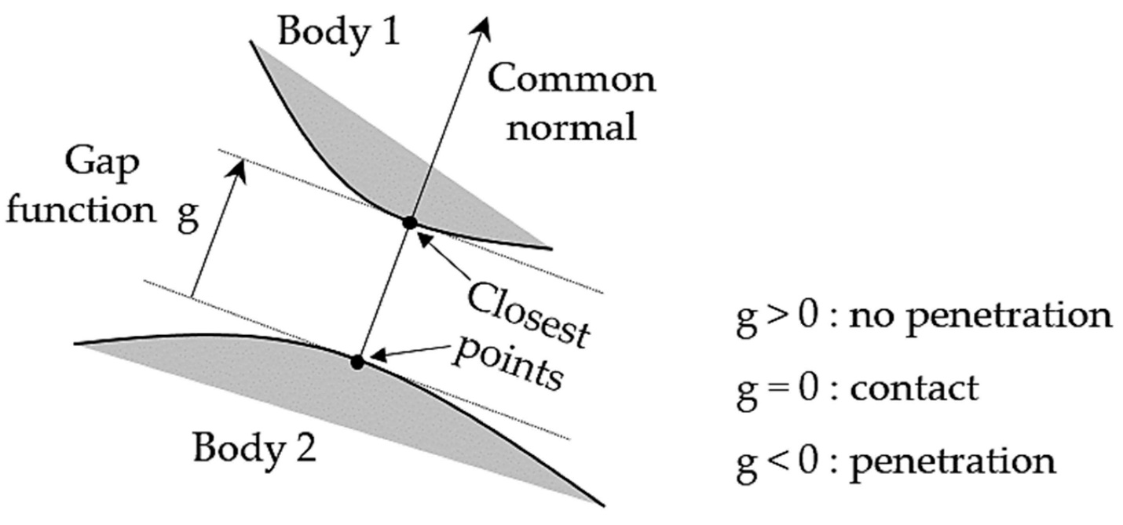
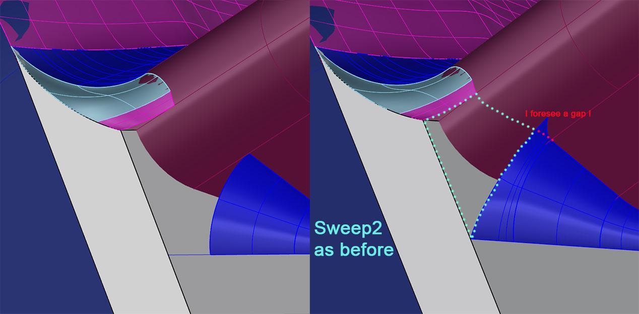

Purpose
# Source: AI Source: Provided by: [Data Path: Persons Table -> ID Column: 1, Name_En Column: Motasem Essam] -> From: [ChatGPT] on [7/25/2026]
A Surface Gap is used to:
- Describe empty space between surfaces.
- Measure separation between 3D surfaces.
- Describe clearance between solid objects.
- Analyze spatial separation in three dimensions.
- Distinguish separated surfaces from touching or intersecting surfaces.

Fundamental Concept
# Source: AI Source: Provided by: [Data Path: Persons Table -> ID Column: 1, Name_En Column: Motasem Essam] -> From: [ChatGPT] on [7/25/2026]
Consider two separate solid objects:
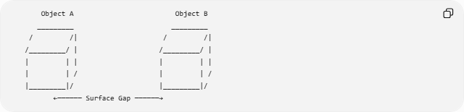
Object A Object B
_________ _________
/ /| / /|
/_________/ | /_________/ |
| | | | | |
| | / | | /
|_________|/ |_________|/
←────── Surface Gap ──────→
The gap is the empty three-dimensional space between the nearest surfaces.
If $P$lies on $S_{1}$and $Q$lies on $S_{2}$, the minimum gap is:
$$\boxed{g=PQ}$$
for the pair of closest surface points.

Mathematical Representation
# Source: AI Source: Provided by: [Data Path: Persons Table -> ID Column: 1, Name_En Column: Motasem Essam] -> From: [ChatGPT] on [7/25/2026]
For two surfaces $S_{1}$and $S_{2}$:
$$\boxed{g=\inf_{P∈S_{1}, Q∈S_{2}}d\left(P , Q\right)}$$
For Euclidean 3D space, if
$$P=\left(x_{1} , y_{1} , z_{1}\right)$$
and
$$Q=\left(x_{2} , y_{2} , z_{2}\right)$$
then:
$$\boxed{d\left(P , Q\right)=\sqrt{{\left(x_{2}-x_{1}\right)}^{2}+{\left(y_{2}-y_{1}\right)}^{2}+{\left(z_{2}-z_{1}\right)}^{2}}}$$

Positive Surface Gap
# Source: AI Source: Provided by: [Data Path: Persons Table -> ID Column: 1, Name_En Column: Motasem Essam] -> From: [ChatGPT] on [7/25/2026]
When two surfaces are separated:
$$\boxed{g>0}$$
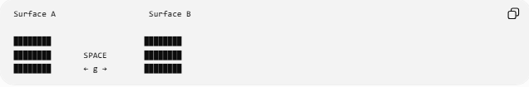
Surface A Surface B

████████ ████████
████████ SPACE ████████
████████ ← g → ████████
There is a positive amount of empty space between them.

Zero Surface Gap
# Source: AI Source: Provided by: [Data Path: Persons Table -> ID Column: 1, Name_En Column: Motasem Essam] -> From: [ChatGPT] on [7/25/2026]
When two surfaces touch:
$$\boxed{g=0}$$
For example, two solid objects may touch at a single point, along a line, or across part of a surface.
A zero gap does not necessarily mean the objects coincide; it can simply mean that their surfaces have at least one common point.

Negative "Gap"
# Source: AI Source: Provided by: [Data Path: Persons Table -> ID Column: 1, Name_En Column: Motasem Essam] -> From: [ChatGPT] on [7/25/2026]
A negative value should generally not be called a gap.
If two solid objects overlap, their surfaces may intersect and the objects penetrate each other. In such a situation, it is more appropriate to describe the relationship as intersection or overlap, rather than a negative surface gap.
Thus:
$$\boxed{g>0→\text{separated}} \\ \boxed{g=0→\text{touching/intersecting boundaries}} \\ \boxed{\text{overlap}→\text{no positive gap}}$$

Types of Surface Gaps

1. Plane-to-Plane Gap
# Source: AI Source: Provided by: [Data Path: Persons Table -> ID Column: 1, Name_En Column: Motasem Essam] -> From: [ChatGPT] on [7/25/2026]
The separation between two parallel planes.
For:
$$ax+by+cz=d_{1}$$
and
$$ax+by+cz=d_{2}$$
the distance is:
$$\boxed{g=\frac{∣d_{2}-d_{1}∣}{\sqrt{a^{2}+b^{2}+c^{2}}}}$$

2. Surface-to-Surface Gap
# Source: AI Source: Provided by: [Data Path: Persons Table -> ID Column: 1, Name_En Column: Motasem Essam] -> From: [ChatGPT] on [7/25/2026]
The minimum distance between two arbitrary surfaces.
$$\boxed{g=\min_{P∈S_{1},Q∈S_{2}}d\left(P , Q\right)}$$
when the minimum exists.

3. Solid-to-Solid Surface Gap
# Source: AI Source: Provided by: [Data Path: Persons Table -> ID Column: 1, Name_En Column: Motasem Essam] -> From: [ChatGPT] on [7/25/2026]
The clearance between the outer surfaces of two separate solid objects.

4. Curved-Surface Gap
# Source: AI Source: Provided by: [Data Path: Persons Table -> ID Column: 1, Name_En Column: Motasem Essam] -> From: [ChatGPT] on [7/25/2026]
The separation between curved surfaces, such as spheres, cylinders, or other curved 3D objects.
Example: Two Parallel Planes
Consider:
$$z=2$$
and:
$$z=8$$
The planes are parallel, so their separation is:
$$g=∣8-2∣ \\ \boxed{g=6}$$
Therefore, the Surface Gap between the planes is 6 units.

Example: Two Spheres
# Source: AI Source: Provided by: [Data Path: Persons Table -> ID Column: 1, Name_En Column: Motasem Essam] -> From: [ChatGPT] on [7/25/2026]
Suppose two spheres have center-to-center distance $d$, with radii $r_{1}$and $r_{2}$.
When they are externally separated:
$$d>r_{1}+r_{2}$$
the surface gap is:
$$\boxed{g=d-r_{1}-r_{2}}$$
For example:
$$d=15, r_{1}=5, r_{2}=3$$
Then:
$$g=15-5-3 \\ \boxed{g=7}$$

Surface Gap vs. Boundary Gap
# Source: AI Source: Provided by: [Data Path: Persons Table -> ID Column: 1, Name_En Column: Motasem Essam] -> From: [ChatGPT] on [7/25/2026]
These concepts are closely related but occur in different dimensional contexts.
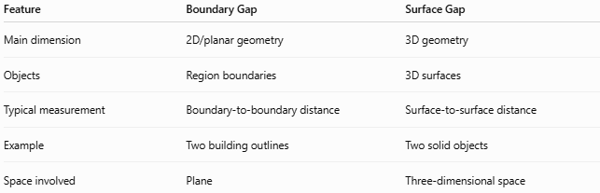
Feature | Boundary Gap | Surface Gap
Main dimension | 2D/planar geometry | 3D geometry
Objects | Region boundaries | 3D surfaces
Typical measurement | Boundary-to-boundary distance | Surface-to-surface distance
Example | Two building outlines | Two solid objects
Space involved | Plane | Three-dimensional space
A Surface Gap can be considered the 3D counterpart of a Boundary Gap.

Surface Gap vs. Region Gap
# Source: AI Source: Provided by: [Data Path: Persons Table -> ID Column: 1, Name_En Column: Motasem Essam] -> From: [ChatGPT] on [7/25/2026]
A Region Gap describes an empty region, whereas a Surface Gap describes the separation between surfaces.
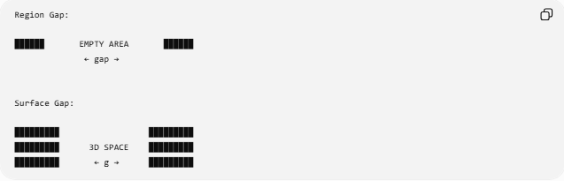
Region Gap:

██████ EMPTY AREA ██████
← gap →

Surface Gap:

█████████ █████████
█████████ 3D SPACE █████████
█████████ ← g → █████████

Relationship with Clearance
# Source: AI Source: Provided by: [Data Path: Persons Table -> ID Column: 1, Name_En Column: Motasem Essam] -> From: [ChatGPT] on [7/25/2026]
A Surface Gap is closely related to clearance.
If a minimum required clearance is $c_{min}$, a design may require:
$$\boxed{g≥c_{min}}$$
For example, two machine components may need a minimum surface separation to prevent physical contact.

Real-World Applications
# Source: AI Source: Provided by: [Data Path: Persons Table -> ID Column: 1, Name_En Column: Motasem Essam] -> From: [ChatGPT] on [7/25/2026]
Surface gaps are important in:
- Mechanical engineering: clearance between machine parts.
- Manufacturing: separation between components.
- Architecture: spacing between 3D structures.
- Robotics: collision avoidance.
- CAD: minimum distance between solid models.
- Aerospace: clearance between components.
- Computer graphics: 3D collision and proximity detection.
- Construction: spacing between structural surfaces.

Key Points
# Source: AI Source: Provided by: [Data Path: Persons Table -> ID Column: 1, Name_En Column: Motasem Essam] -> From: [ChatGPT] on [7/25/2026]
- A Surface Gap describes separation between surfaces in three-dimensional space.
- Its minimum value is the shortest distance between the surfaces:
$$\boxed{g=\inf_{P∈S_{1},Q∈S_{2}}d\left(P , Q\right)}$$
- $g>0$indicates separated surfaces.
- $g=0$indicates that the surfaces touch or intersect.
- Overlapping objects do not have a positive surface gap.
- Surface Gap is closely related to 3D clearance and minimum surface distance.

Conclusion
# Source: AI Source: Provided by: [Data Path: Persons Table -> ID Column: 1, Name_En Column: Motasem Essam] -> From: [ChatGPT] on [7/25/2026]
A Surface Gap is the three-dimensional separation between two surfaces or surface regions. It is normally quantified by the minimum distance between the two surfaces and is particularly important when analyzing the clearance and spatial relationships of 3D objects.

